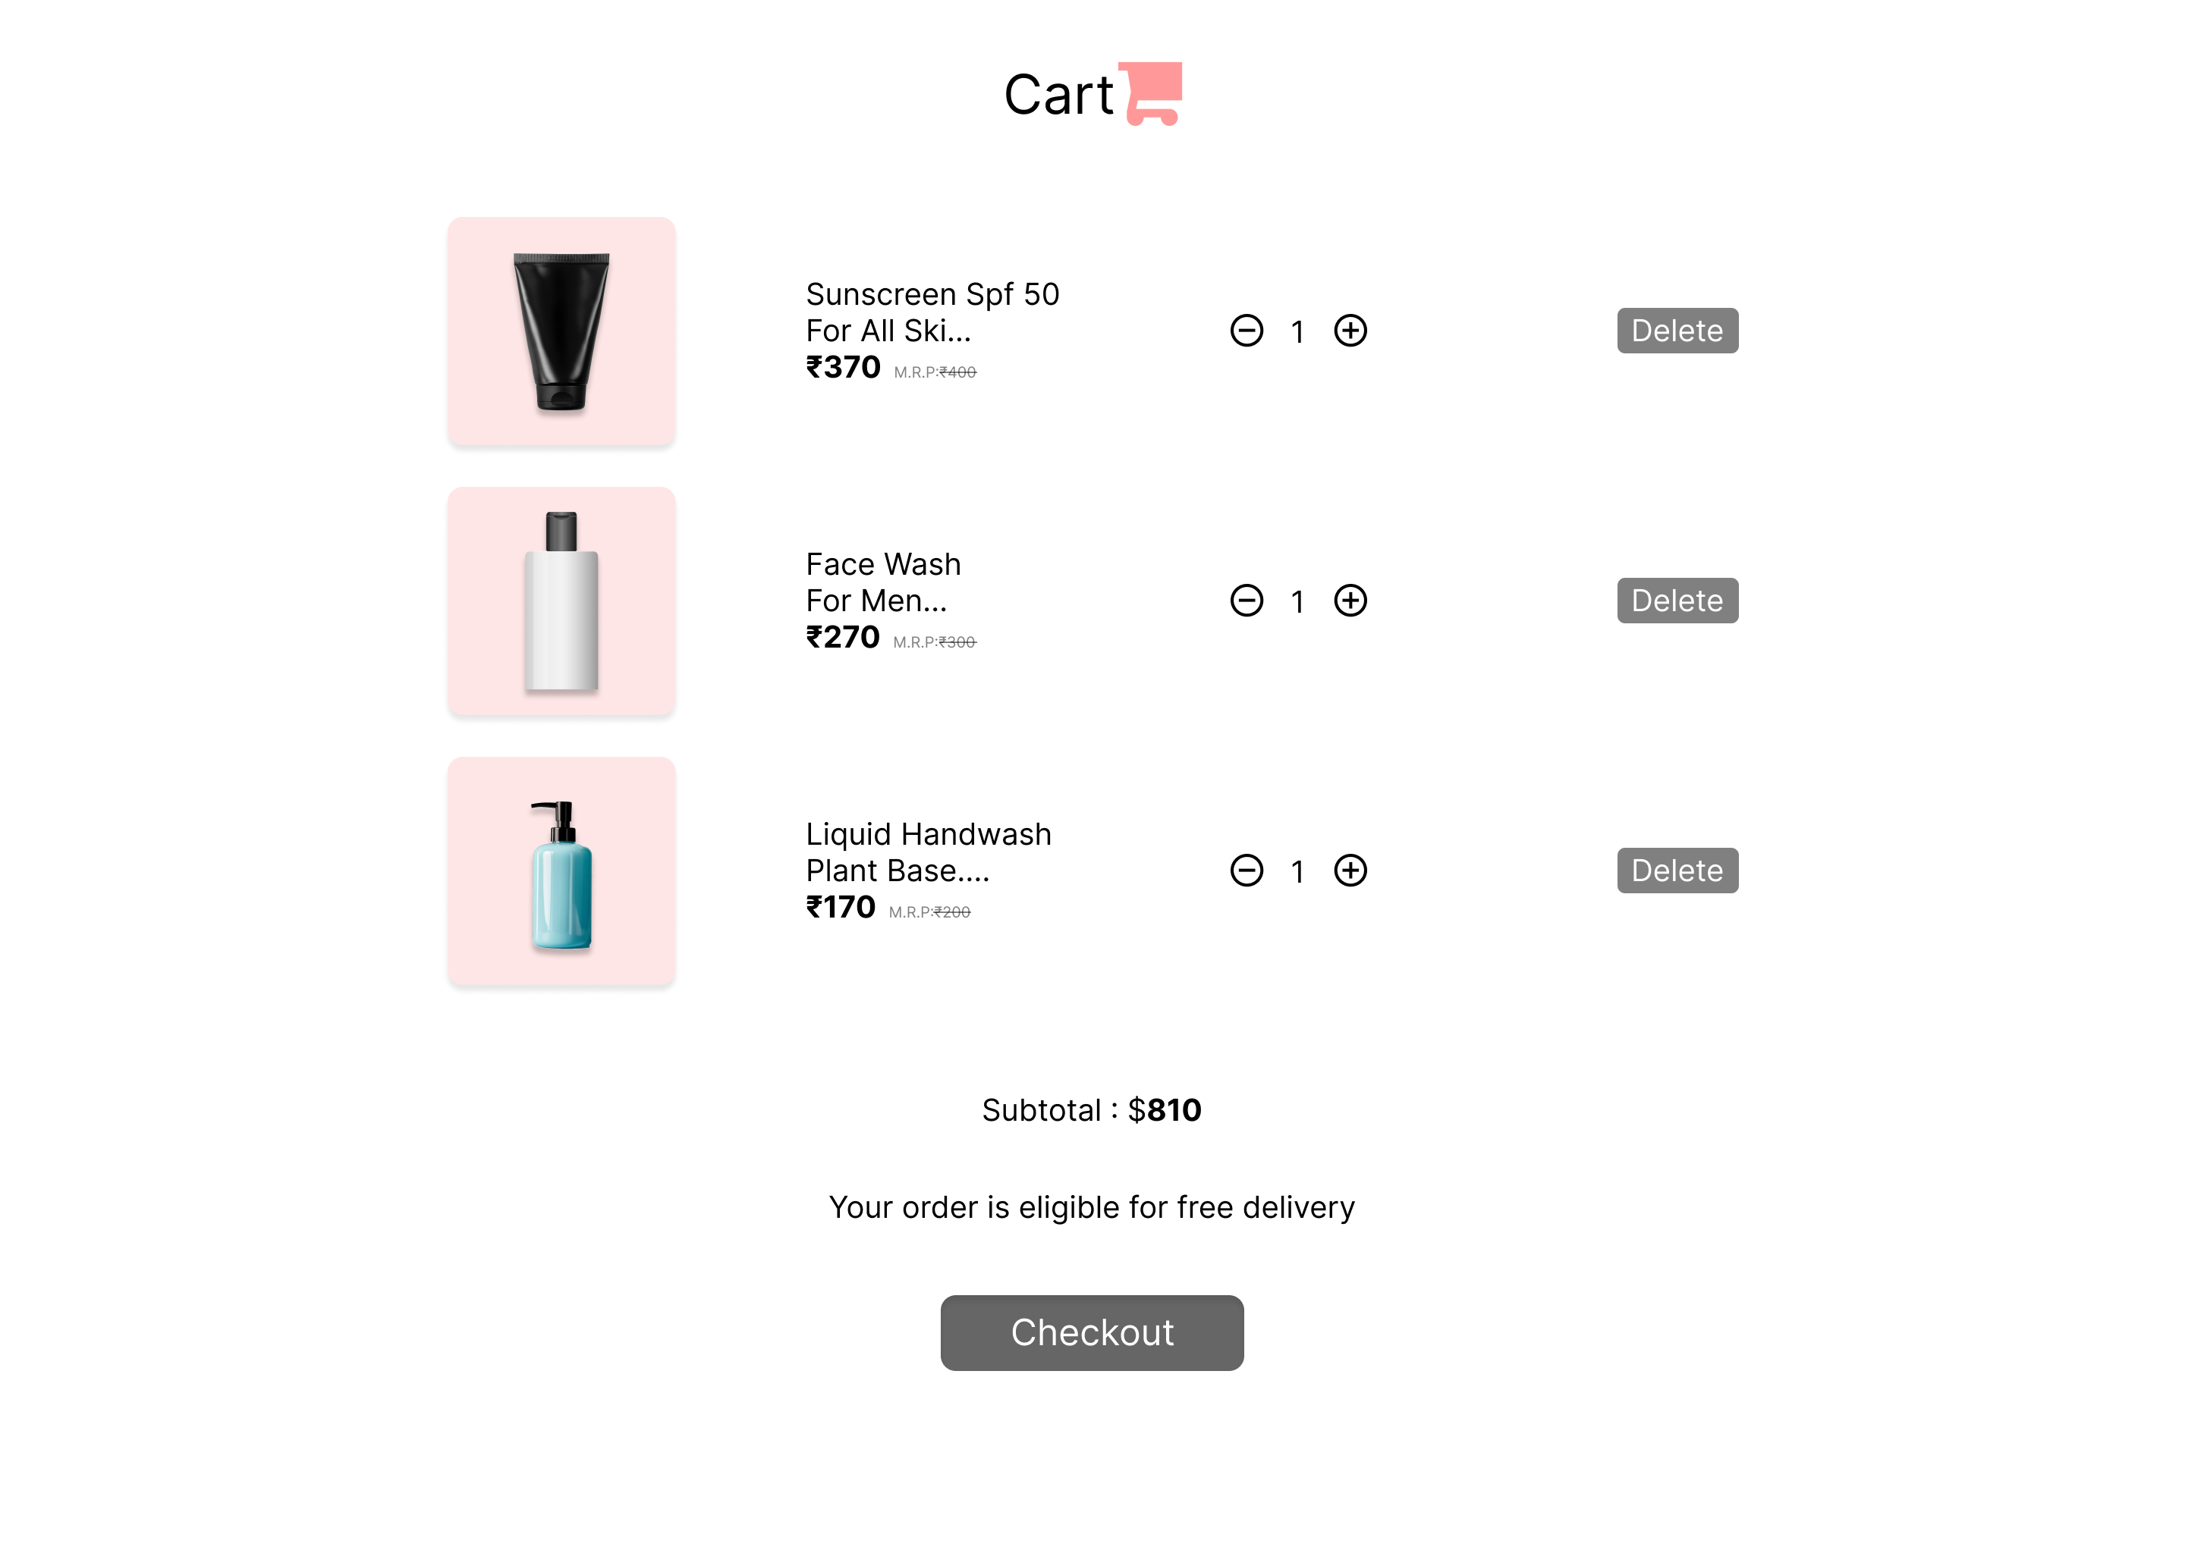link: https://www.figma.com/design/EKRlouWmMujucLii2Fg82g/Car_Shop_Manager_Portal?node-id=204-82&t=4UgqlAchv27VkV8s-1

